**MIS-637**

**Data Analytics and Machine Learning**

**Stevens Institute of Technology**

**School of Business**

**Prof. M. Daneshmand**

**Problem Statement:**

To predict the short term electricity load, it is needed to implement machine learning techniques for time series data of a local grid stattion.

Through this project focus is made on short term load forecasting (STLF), prediction of loads for time leads from one hour up to one week ahead. It is used to maintain optimal performance in the day-to-day operation of electric utility systems.

The dataset is taken from Kaggle.com.

Time series models, regression models and the Kalman filter are some of the conventional methods that we are going to use.

**Sample Data:**

We collected our data from a local grid station, which they already had. It is a ten years old data and consists of 32000+ rows, which is quite an enough data for our work.

It has four columns:

‘DATE HOUR MINUTE VOLUME ‘

The data shows at which date, hour and minute how much was the load at the station.

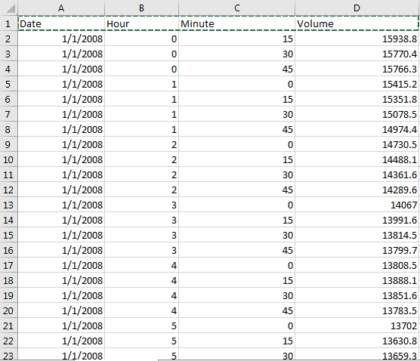

**Relevant Methodology/Algorithm:**

There are different data modelling techniques used in this project. The language used is Python and the IDE used is ‘Spyder’.

Algo’s used:

* ARIMA
* LINEAR REGRESSION
* ANN
* SVM
* LSTM

**Software Package:**

Anaconda, Conda installed tensorflow and Conda installed keras.